
GIS Library Tutorials – Introduction to ArcGIS Online - 7

Spatial analysis : Buffering

With ArcGIS Online you can show the wind turbines on a map and then create a buffer around these to demonstrate, for example, that proposed wind turbines are at a suitable distance from protected woodland areas.
You can create buffers around Points, Lines or Polygons.

Zoom into the area of your map where you have placed the wind turbines

Left click on the Analysis tab to open a new menu of options

Left click on Use Proximity

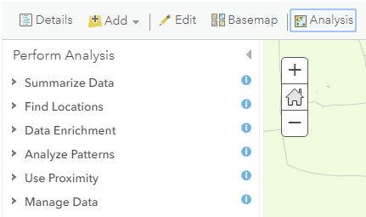

Left click on Create Buffers

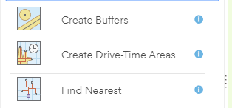

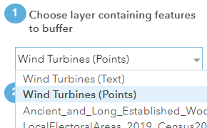
From the pull-down menu left click on the layer which you wish to create a buffer around. In this example it is the Wind Turbine (Points) layer.

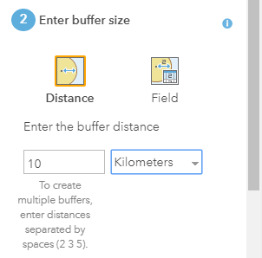
Left click on Distance and then set the size of your buffer by typing in a number for the radius distance of the buffer
Next left click on the pull-down menu to select the measure of distance you wish to use, i.e. kilometres, miles, feet, etc
Left click on Options



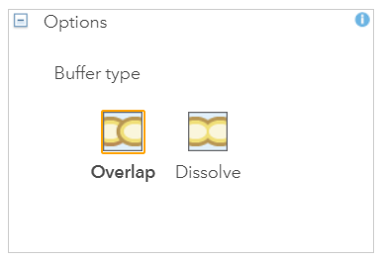
The next step is to left click on Dissolve.
Choosing this option means that all of the individual buffers will be merged into a single buffer
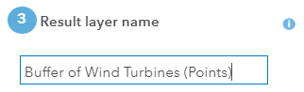
Rename the buffer to a more meaningful name by typing text into the Result Layer Name box
Left click to tick the checkbox Use current map extent to set extent of the view shown on your map.
Left click on Run Analysis
The Buffer will be saved in your map account

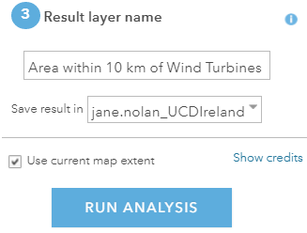

When the Buffer has been created it will appear in your table of contents as another layer. Make sure the Content tab is selected, that your buffer layer has tick in checkbox so that it is visible on the map and that the legend icon is clicked if you wish to see its symbol (blue polygon in this example)
Zoom out on your map to view the entire buffer area.

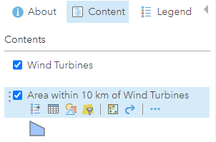

Your buffer will be displayed on the map as shown here. Left click within the buffer to read the measurement details.

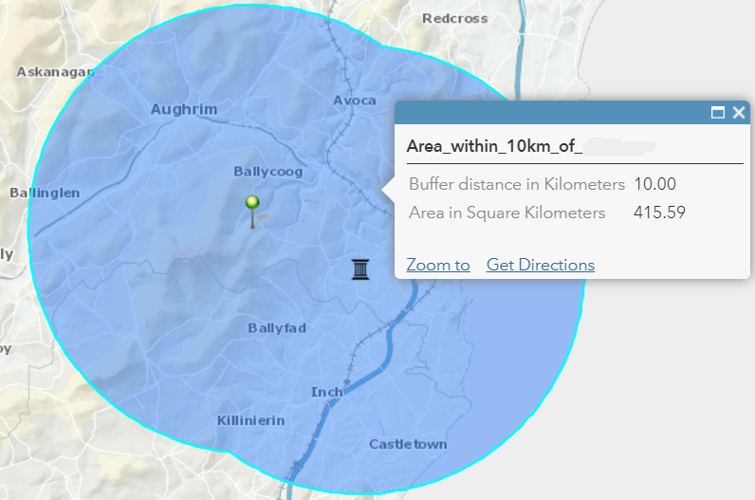
wind turbines

Left click on the Save button again
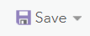

To change the colour or transparency or outline of the buffer left click on the Styles option

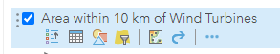

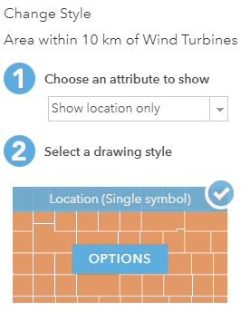
For this example, leave the default option Show Location Only and then left click on Options

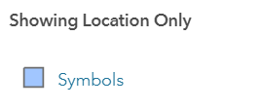
Left click on the coloured square next to Symbols

To make the buffer transparent and to outline it with a different colour do this:

Left click on Outline and left click on a strong colour

At the Pattern option, left click on a dashed line

Left click on Fill (don’t click on a colour)

On the transparency bar move the slider to 100% to make the buffer transparent

Left click on OK

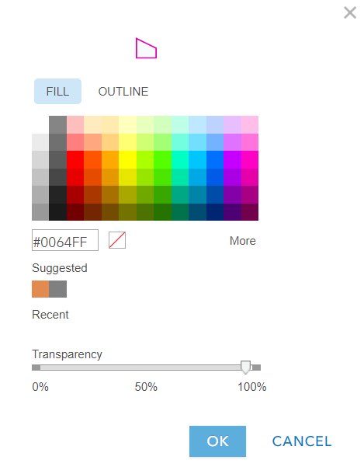

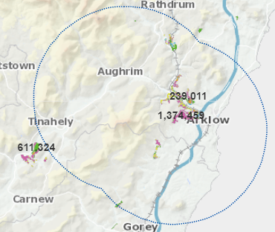
You should then have a map similar to this.

On the left-hand side at the bottom, left click on OK



On the next screen, left click on DONE



Save your map again

